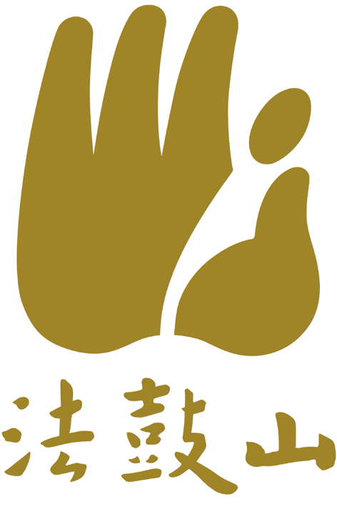
Application Form for Taking Refuge and the Five Precepts

(※Boxes surrounded by dotted lines to be filled in by DDM personnel.)
Date of Taking Refuge | (Y.M.D) | Computer No. |  | Dharma Name
Venerable Giving the Refuge |  | Venue

◎Please fill out all fields marked with an asterisk (＊) for our database, and to allow us to provide care and services in the future.
＊Name  (in upper case) | Last name |  |  | ＊The last four digits of your ID or passport number.
 | First name |  |  | Nationality
＊Birthday | (MM/ DD/YYYY)  / / |  |  | ＊Gender |  |  |  | □ Male |  | □ Female
◎Please provide at least TWO phone numbers so you won’t miss out on any activity information.
Office Phone | ( ) Ext. | Cell Phone
Home Phone | ( ) | E-Mail
Mailing Address |  |  |  |  | Zip Code
Permanent Address |  |  |  |  | Zip Code
School Name |  |  | Major Field of Study
Company |  |  | Title or Position
Who Referred you here?(Where did you get the message?)

◎To protect your privacy and conform to local laws and regulations, please read the following information and sign at the bottom of this page to confirm your agreement.
1. To promote Buddhist practices, education, study, care, and services we will share via computer the personal information provided in this form within the Dharma Drum Mountain organization and cooperating entities and locations to continuously provide care and services. Your information will NOT be used for any purposes other than those outlined above.
2. You may request to check, modify, delete, or stop the use of your personal information.
3. You may choose whether or not to provide personal information. However, if you do not provide personal information, or your information is incomplete, we may not be able to provide you with comprehensive care and services.
Signature：_________ Date：(MM /DD/YYYY)

